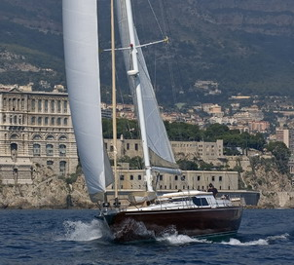
DESIGN-GROUP "ALA"

SHIP DESIGN / PROJECT DEVELOPMENT /
TECHNICAL SUPPORT

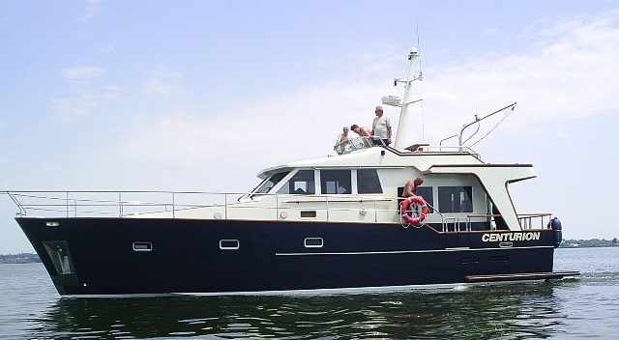

IDEA - SOLUTION - PROJECT - REALIZATION

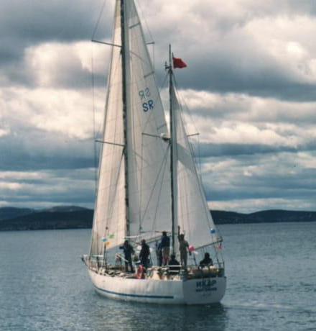 | More than thirty years ago by student design bureau “YAHTA”, at the Nikolayev Shipbuilding Institute was worked out a project of 16 meter sailing yacht “IKAR”, which received the code name NKI17. Lev Zaburdaev, Alexander & Anatoly Kuznetsov took the most active part in the development of this project. Yacht was designed and built specifically for the first Soviet circumnavigation, which took place in 1987-88. Kuznetsov brothers were members of the crew. Anatoly – first mate, Alexander – deck officer.  These three persons became the “founding fathers” of the company, whose goal was ship design and support of building small-tonnage vessels.  In memory of the Nikolayev Shipbuilding Institute (now the National University of Shipbuilding), saved encoding in which the number indicates the project sequence number (NKI).  Since 2000, Design-group “ALA” is a “forge of personnel” of young specialists in shipbuilding and yacht design.
Design-group “ALA” has in its archive more than 100 projects of small-tonnage vessels. Among these projects are sailing & motor yachts, fishing & specialized vessels. Special attention was paid to high-speed craft projects. Also were developed special-purpose vessels projects.
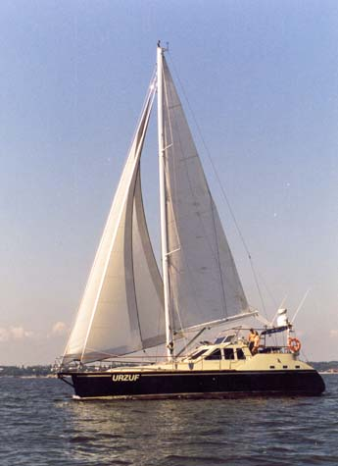
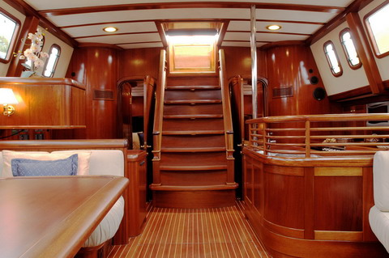
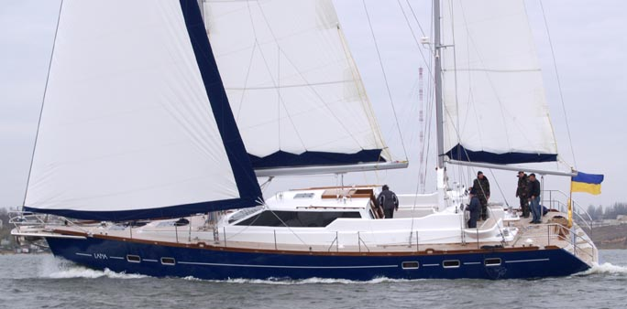
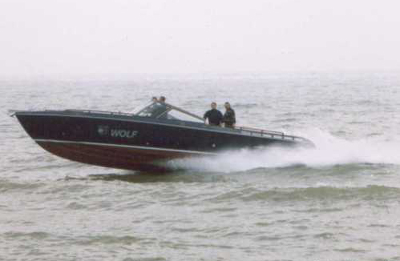
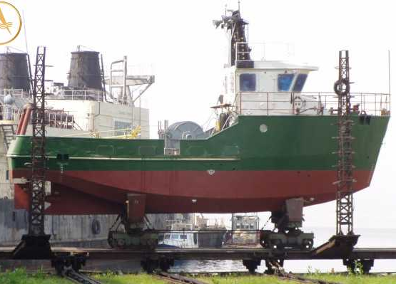
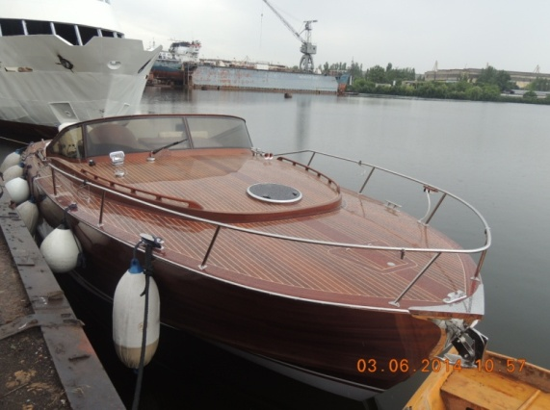
Design-group specializes on vessels and crafts with hull made of shipbuilding steel, light alloy and wood. Long-term studies of leading experts allow us to apply non-trivial solutions in design practice and create optimal hull constructions.
Qualification of specialists allows making design and working out drawings of ships and specialized constructions of any difficulty.
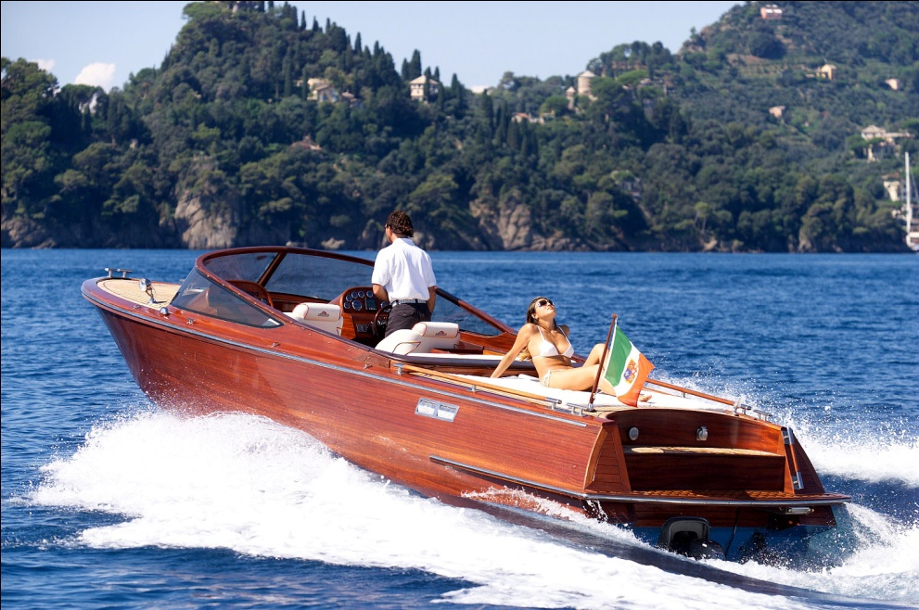
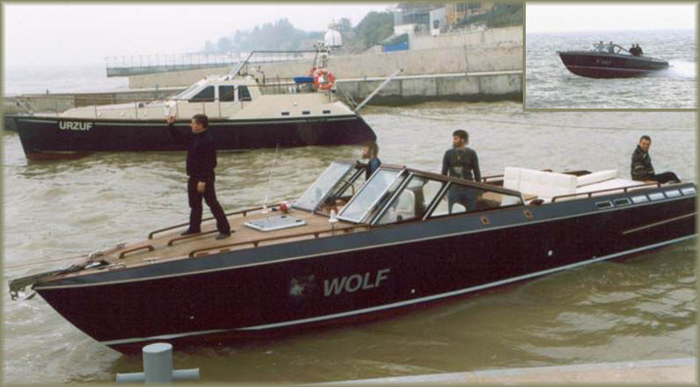
Company has ability and experience of work with any Classification Society. All design and technical documentation issued bilingual (Russian / English).

Design-group “ALA” was the first company in Ukraine, which certify vessel according to CE requirements.
In addition to practical design and engineering, the company’s specialists are engaged in scientific and research works:
- "Engineering methodology of the underwater discharge wing design for high-speed crafts and its verification according to the results of field tests" (published in the collection of “Marine Intellectual Technologies”)
- "Feasibility analysis of materials hull structures for small vessels" (published in “East European Scientific Journal”)
- "Determination of weight of hull structures of motor-sailing yachts, power boats and multi-purpose crafts in the early design stages" (published in the collection "International Scientific and Research Conference named after prof. V.V. kozlyakov)
- "Field limitations and its impact on the quality of design solutions for design of structures of small ships" (published in “East European Scientific Journal”)
- "Cost analysis of the yacht under construction" (published in “Boats and Yachts” magazine)

KEY SPECIALISTS OF THE COMPANY

Alexander Kuznetsov – CEO Design-group «ALA”, chief engineer. Experience -42 years. | Anatoly Kuznetsov – leading specialist, Doctor of Science. Experience – 42 years. | Taras Kot – project manager. Experience – 18 years.  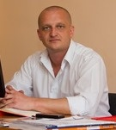 | Alexander Onufriev – hull structure. Experience – 14 years.  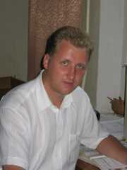
Olga Vasil’eva – exterior & interior ddesign. Experience – 15 years. | 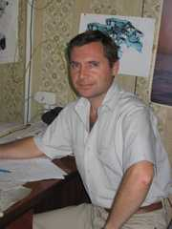  Oleg Rudiakov – hull systems, mechanical drawings. Experience – 22 years | 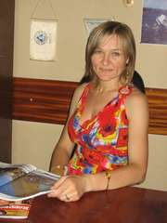  Olga Nugaichenko – furniture, outfit. Experience – 14 years. | Alexander Chernozub – electrical systems, navigation. Experience – 48 years.  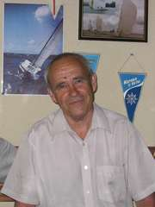
 | Yuri Chuchko – ship design, Doctor of Science. Experience – 39 years. | Maria Zagoruiko – outfit, hull structure. Experience – 12 years.  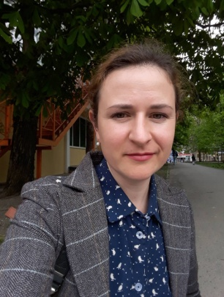

yachts built according to our projects were exhibited at exhibitions in Dusseldorf, Miami, Cannes and exported to Italy, Russia, germany, Greece, USA, Holland and New Zealand.
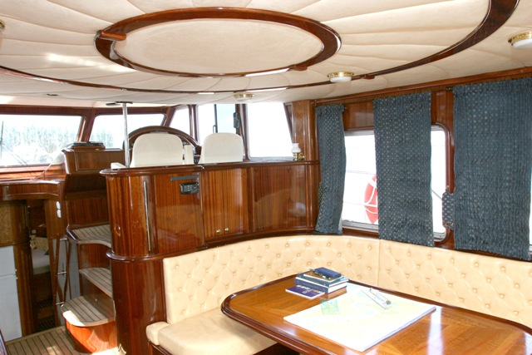
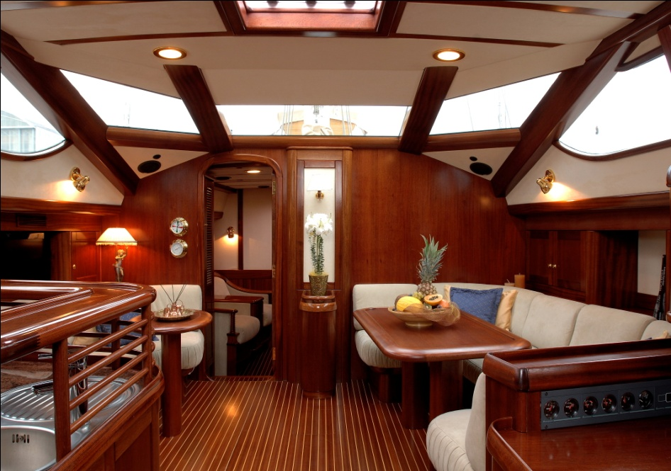
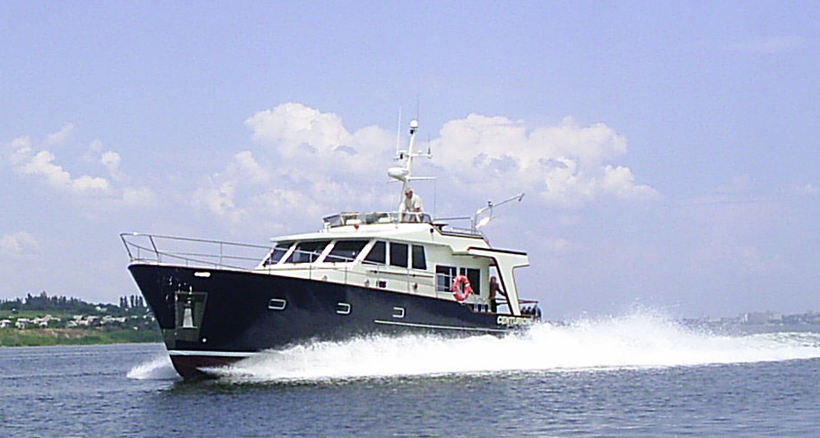

CONTACTS
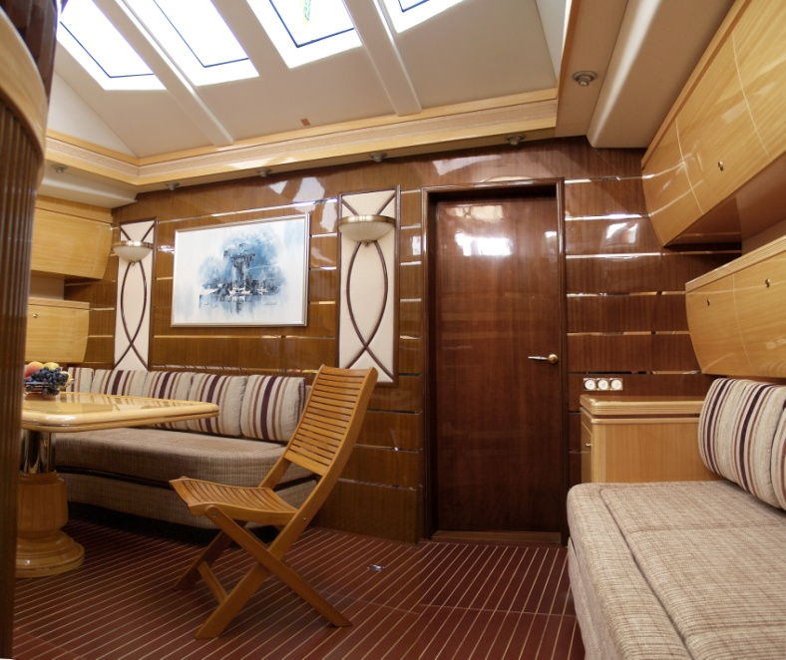
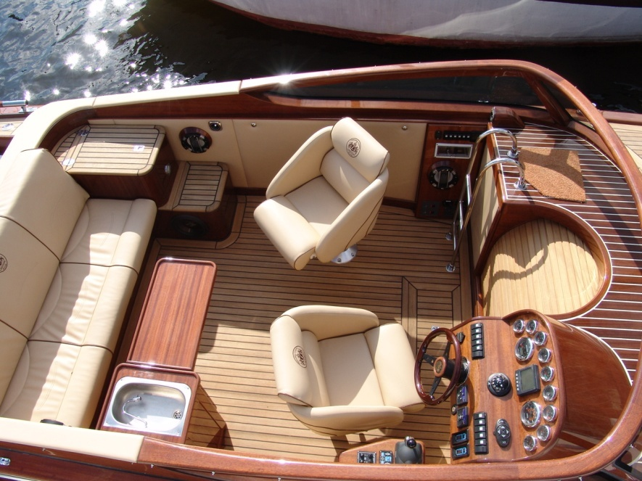
Design-group “ALA”
Ukraine, Nikolayev, Rabochaya str. 2A, of.501.
ph.: +380503942119
+380503944081
e-mail: aleksandrkuznec47@gmail.com
anatoly1954.kuznetsov@gmail.com

